Hand-Made by Machines

The Rhyme and Reason of Creativity

In Humans and Machines

Tony Veale

We praise our machines for their consistency, their precision and their speed, but never for their creativity or their insight. And why should we? Creativity is a very human-centric concept, after all, and the popular imagination has good reasons for placing humans and machines at opposite ends of the creativity spectrum. If we want our machines to exhibit the kinds of behavior that humans call creative, we shall just have to build (or teach) our machines to think more like we do. It can come as a surprise then to learn that the converse is also true: humans can often be more creative by learning and choosing to act like machines! Hand-made By Machines explores the fascinating ramifications of this controversial claim, by staking out a productive middle ground between the worlds of human and machine creativity.

Rules of Engagement
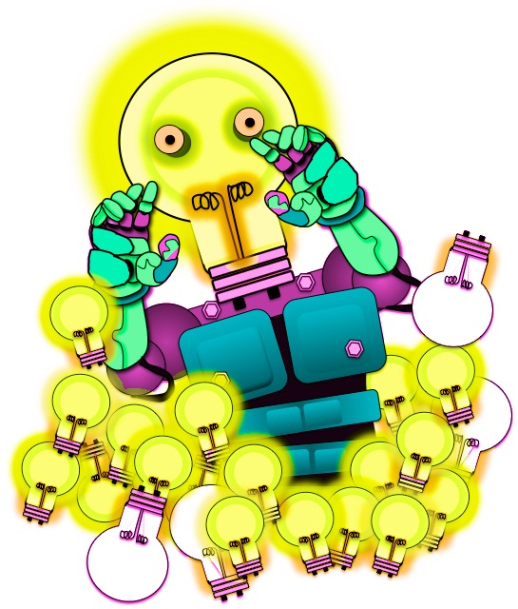
The Hand Of Creation
In advertising, few words are more effective at conveying a sense of quality and craftsmanship than “hand-made” and “artisan”. Even when emblazoned – however incongruously – on plastic-wrapped commodity items in discount super-stores, the words impart the warm-and-fuzzy feeling that our purchases have been shaped by people who care about what they create. Though modern advertising instills a certain prophylactic cynicism, it’s still surprising to learn that the legal basis governing the fair use of these terms is just as fuzzy and ill-defined as the feelings they engender. Indeed, unlike the labels “free-range” and “organic”, which are subject to strict rules governing their usage, the words “hand-made” and “artisan” can be used by advertisers with abandon, untrammelled by any considerations of truth, logic or common-sense. Rather like the apparent convenience of “nails manicured while-u-wait”, the words mean only as much as we, as consumers, are charitably willing to grant them.
For many, the words will evoke a bucolic setting in which experienced craftsmen and their eager apprentices lavish great care and attention on each and every item. In reality, however, many cottage-industry products are “hand-made” only to the extent that a fast-moving assembly line of rubber-gloved, hair-netted employees will allow. What concerns us about this reality is not the ethics of advertising but our perceptions of quality and authenticity in the creative process, and how these are shaped by tacit convention. For bound up in the simple terms “hand-made” and “artisan” is a complex set of unspoken expectations that shape how we perceive beauty, truth and creativity in everything around us. The yawning gap between the poetic ideal and the prosaic reality applies as much to our appreciation of creative computers as it does to our appreciation of artists and artisans, or indeed, to any of the “hand-made” products we buy and consume. As computers begin to shoulder a growing share of the creative burden in the design and generation of new products and ideas, we will need to give more thought and substance to these tacit assumptions. This then is the principal goal of this book: to explore the role of perception, emotion and logic in computational creativity, and to show that the issues that govern creativity in computers are not that different from those that shape it in humans.
To begin with, it is worth noting that the sense of quality evoked by the term “hand-made” has very little to do with the possession or use of actual hands, at least in any literal sense. Large technology companies, for example, are known to outsource the manufacture of smartphones and other electronic gadgets to countries in Asia where labor costs are low, and where, despite the sophistication of specific components, products are typically hand-assembled by a phalanx of low-paid workers. Yet the fact that these hi-tech products are, in a real sense, “hand-made” is more often a source of shame than of pride for these companies. Conversely, one could give the robots on an automated assembly-line the robotic equivalent of hands, yet consumers would still balk at considering the products “hand-made”, no matter how sophisticated or life-like the appendages. The hand of “hand-made” signifies much more than manual assembly, and represents instead an idealized notion of how products should be constructed, via a tight integration of manual dexterity, attentive oversight and mental engagement. In this idealized integration of hand, eye and brain, a hand-made object is one in which its maker applies both manual effort and critical judgment. More importantly, it is one that receives individual attention, so that any unanticipated issues can be handled by the maker on a case-by-case basis, by applying the relevant experience and aesthetic sensibilities. Whether one is making smartphones or hotcakes, “hand-made” implies a level of conscious engagement that has surprisingly little to do with the hands and quite a lot to do with the mind.
The mistakes that result from a lack of conscious engagement in otherwise “hand-made” products can be both illuminating and hilarious. Consider the case of Wegman’s bakery in New York, which will bake you a cake bearing any text or digital image that you care to provide via email. An employee describes the bakery’s work-flow as follows: “We just cut and paste from the email to the program we use for printing the edible images. We are usually in such a hurry that we really don’t have time to check, and if we do the customers yell at us for bothering them.” A printer loaded with food dyes is a novel tool for a bakery to use, but it remains a tool nonetheless, and a Wegman cake can still qualify as “hand-made” if the baker takes the time to properly engage with each new order. Yet technology can throw the most unexpected of spanners into the works. Microsoft Outlook, for instance, inserts proprietary HTML tags into its messages, for the viewing pleasure of recipients who happen to use the same email program. Those using a different program, such as Wegman’s, may not always know what to do with these additional tags, if indeed they notice them at all as content is hurriedly cut-and-pasted from one place to another. While blunders such as the genuine example of a Wegman’s cake in Figure 1 are hard to anticipate, silly mistakes inevitably arise from a lack of engagement in any task. While the trained hand does its work, the mind is frequently in hands-off mode.

Happy Birthday
To
Elsa / Aunt Elsa

<!—[if !supportEmptyParas]--> <!—[endif]-->
12/01/1926 to 12/01/2006
<!—[if !supportEmptyParas]--> <!—[endif]-->
FRIÛL to Binghamton
<!—[if !supportEmptyParas]--> <!—[endif]-->
“Bon complean” alla piu’ bella “polentona” di Ciserils.
<!—[if !supportEmptyParas]--> <!—[endif]-->

Avanti a cent’anni!

<!—[if !supportEmptyParas]--> <!—[endif]—
>

Figure 1. A genuine (if atypical) example of a birthday cake from Wegman’s NY bakery, with an unexpected sprinkling of raw HTML courtesy of Microsoft Outlook. <b><em>Delicious!</em></b>
So how might a computer apply itself to a production task in ways that match our fuzzy understanding of the labels “hand-made” and “artisan”? The key is surely more than mere physical embodiment – though this may give some systems a compelling marketing advantage – but active engagement, both of the senses and of the sense-making faculties. While any well-defined problem can be successfully automated in software by first identifying an appropriate set of logical rules, creative choices often reject the predetermined decision structure of rules. Moreover, this kind of formalization often produces brittle, hide-bound thinking. For when rules and processes are applied automatically, without consideration of possible exceptions, they inevitably produce mistakes that would be caught by even a little conscious engagement, such as the obviously ill-formed cake of Figure 1 that slipped past Wegman’s employees. Whenever one talks of the rigid application of rules, one invariably thinks of machines: thus, one is said to be “crushed by the machine” whenever society enforces the primacy of a general rule over the individual merits of a specific case. (Or consider the idiocy that results when an otherwise sensible food-safety rule is applied without exception, so that even a jar of peanut butter must caution buyers that it “may contain nuts”). Unlike the stereotype of the rigidly-focused, rule-governed machine, humans bring a lifetime of diverse experience to every task, and can draw on this experience to judge each exceptional case on its individual merits.
In contrast, while computers excel at applying a formal standard that is grounded in explicit rules, and can efficiently detect when something fails to meet this standard, they fare less well at handling unanticipated situations in sensible ways (such as Wegman’s HTML cake), or indeed, of recognizing that an exceptional case is sometimes aberrant in a way that is novel and apt (suppose the HTML cake had been intended for Tim Berners-Lee, or more poetically, for a Microsoft software developer; it might then be considered apt rather than inept). Of course, one can always program a software system with ever more rules, to anticipate a richer taxonomy of exceptions with an ever more nuanced set of predetermined responses. However, to the chagrin of Artificial Intelligence (AI) researchers, who refer to this dilemma as the frame problem, new rules often breed new exceptions of their own, and so require even more new rules to fix, in an ever-spiraling bureaucracy of rules that govern rules that govern rules.

Free-Range Computing
But the solution is not to abolish rules outright – a computer without rules would be as inert as a brain without neurons – but rather to re-conceptualize the function of rules in our computational systems. Imagine, for instance, if Wegman’s bakery were to fully automate their bespoke cake creation service, to work unaided and unsupervised from a customer’s email to a customer’s front door. For convenience, let’s call the mechanized version of Wegman’s bakery service Wegmachine. Now, knowing as we do that a customer’s intent can sometimes be lost in translation, it seems eminently sensible to include rules that anticipate the kind of formatting errors that can occur at the juncture of different pieces of technology in the production pipeline. But while we may generalize a little from the negative experience of poor Aunt Elsa, our rules can only ever cover the kind of exceptions that we already know about. No matter how Jesuitical our Wegmachine’s decision processes become, the likelihood remains that it will continue to fail us in silly ways, ways that appear obvious after the fact but which we could not have been predicted before the fact.
A system doesn’t need hands to be hands-on, though greater engagement is certainly facilitated by being able to physically interact with, and derive feedback from, the raw form of a product. But the brittleness of the a priori rules in our hypothetical Wegmachine means that even at the level of abstract representations – that is, when working with a conceptual model of the desired cake, rather than with the cake itself – our system would still lack the flexibility to handle unexpected departures from its hard-coded norms, and so could not knowingly craft an aesthetically pleasing result. Here lies a pointed irony: the rules of a hand-crafted Wegmachine cannot produce a hand-made result, even if the system itself has been lovingly hand-made by its hypothetical developers. Just think of the coding effort that such a system would require, and of all of the manual tuning it would subsequently demand, to identify an optimal interplay of rules for each of its imagined use-cases and for all of the anticipated ways in which these use-cases might be subverted. But the irony is sharper still: the best way to salvage the Wegmachine is to reject the idea of delicately hand-crafted rules, and to allow the machine to learn and evolve its own rules and its own criteria for aesthetic judgment. Since such a system would require a large and judiciously chosen diversity of examples from which to learn, this version of the Wegmachine should more aptly be labeled hand-reared than hand-made.
Just as the skills of human artisans are honed by years of training and practice, our computational Wegmachine would likewise grow into its job, though machine-learning being what it is, its apprenticeship would be short, swift and turbocharged. Even the task of feeding the machine relevant training images of representative cakes need not be as laborious as it sounds. In addition to images of decorated icing, the system could also be periodically fed a stream of relevant images from Christmas cards, birthday cards, Mother’s Day and Father’s Day cards, and so on. For every holiday H for which one might conceivably buy a greeting card or a cake – and there truly is a card for every occasion – pictures of representative H-cards with the corresponding imagery and language could be automatically harvested from the Web and used as further training data (though our machine would be well advised to avoid ironic sites like wrongcards.com). Language models can be derived from the cards’ pithily expressed sentiments, so that our Wegmachine can learn what one is likely to say (and what a cake is likely to express) in diverse fine-grained contexts, from “It’s a Girl!” to “Today You Are a Man.” Delicate cultural distinctions that affect the choice of verbal and visual elements, such as the subtlety of “Happy Christmas” versus “Happy Holidays”, can also be learned, allowing Wegmachine to anticipate the unspoken wishes of a client. Using basic image analysis techniques, the machine might also learn to associate clusters of visual features (such as colors, shapes, textures, font sizes and styles, etc.) with specific themes, target groups, ages and genders (since e.g. birthday cards are typically organized by age and by gender of the recipient).
Once our Wegmachine has learned to build nuanced models of the look and feel of many different cakes in fine-grained contexts (e.g., a birthday cake for a 7-year old girl), it can use these models to perform a sanity-check on every cake order that it receives by email. Thus, should an order happen to be mangled by an over-zealous mailer like Microsoft Outlook, a variety of alarm bells would be triggered, both at the language level (who ever saw supportEmptyParas on a cake?) and at the visual level (too many angle brackets and other punctuation). But more than this, a well-trained Wegmachine should also be able to use appropriate imagery of its own choosing to decorate a simple text-only cake request. This imagery, which would be learned from its stock of exemplar cakes and its even larger inventory of greeting card images, could be chosen to match the relevant themes (e.g. birthday, celebration, youth) to appropriate colors, contours and textures (e.g. pink balloons, fluffy clouds). Or more ambitiously, our Wegmachine might even use a non-photo-realistic picture generator (of the kind explored by computational creativity researchers) to produce its own pictures or collages to decorate the customer’s chosen text. In such a case, the machine would generate a diverse pool of candidate images, before choosing the image that best matches its learned model of what constitutes an acceptable cake.
This hypothetical machine is certainly no HAL-9000, and hardly resides at the pinnacle of AI ambition, but that is largely the point of the exercise. Just how much should a machine have to do, and how reliably should it do it, before we judge it to be more hands-on and engaged than an equivalent human who is simply going through the motions? Our Wegman versus Wegmachine is more Gedanken than Gebakken then, more a thought experiment in AI than an elevator pitch for a new wave of mechanical bakers. But as a thought experiment, it draws on proven technologies to show the viability of imbuing a tightly-focused software/hardware system with a range of artisanal qualities and sensitivities. Certainly, our imaginary Wegmachine is capable of showing more interest in the design needs of its customers than is exhibited by humans who hurriedly use cut-and-paste to produce results like that of Figure 1. While humans may justify a lack of engagement and an indifference to a client’s needs with the claim that “customers [would just] yell at us for bothering them”, a Wegmachine could use its well-trained aesthetic judgments about what constitutes an unexceptional cake – in terms of the imagery and language primed by the request email – to limit its bothersome questions to those customer requests that poorly fit its expectations.
No matter how comprehensively we trained our Wegmachine, it would still be capable of making mistakes. Ironically, the more comprehensive and diverse the machine’s training set – which might include religious iconography or graphic erotica – the greater its potential for embarrassing mix-ups. Yet to hope otherwise is to miss a key point of the thought experiment. For instance, suppose a customer emails a request for an Easter-themed cake, and Wegmachine selects and prints a bloody Crucifixion scene (as acquired in training from a dour religious card, perhaps) rather than a jolly image of the Easter bunny. Such a mistake would be of a very different character to the real-life cock-up shown in Figure 1. Mistakes of interpretation, like the former, are indicative of a level of conceptual engagement that is entirely absent from mistakes like the latter. For one needs to engage at the level of ideas – no matter how shallow this engagement might be – before mistakes of interpretation are even possible. While some mistakes are evidence of a thought process gone astray, others can be evidence of a total absence of thought in the first place. Both kinds deserve criticism, but the former is a far more interesting and desirable state of affairs. The goal of computational creativity is not to build machines that never make mistakes, but to build machines that know enough to make interesting mistakes.

An Age of Mechanical Artisans
If the Advertiser’s Code is agnostic on the meaning of “artisan”, we can always look to a dictionary for answers. Merriam Webster provides two related senses:
- a worker who practices a trade or handicraft
- one that produces something (as cheese or wine) in limited quantities often using traditional methods
We might also add that our idealized notion of an artisan emphasizes the importance of skill, training, individuality and tradecraft, while the etymological kinship to “artist” is also suggestive of some degree of artistic pride. Thus, we are unlikely to grant artisan status to a plumber, an electrician or a barman, but carpenters, tailors, bakers and cocktail makers may all make the grade. But how does our hypothetical Wegmachine fare when judged against these criteria? We can certainly think of our machine as a dedicated worker, and of the production of bespoke cake designs as a trade, or indeed a handicraft, given our arguments for Wegmachine’s hands-on engagement with its duties. Since our Wegmachine can hardly be said to use traditional methods – but neither of course do Wegman’s human bakers – the issue of Wegmachine’s artisanal standing thus hinges on the sparing use of its skills on limited runs of individualized products.
Though creative people are often appreciated for their fluency of production – the ability to generate many different ideas or solutions – we often look down on creators who produce with too little variety on too large a scale. Implicit in our appreciation of artistry in a contempt for those who “sell out”, for a producer who produces too much too quickly can hardly be said to invest enough care and attention into each individual item. Though creators need to make a living, we prefer them to sell themselves in inches rather than yards. Artisans produce in limited quantities not because they want to manipulate market prices, but because hand-made products simply do not lend themselves to mass production. (Conversely, producers sometimes manipulate the availability of stock to give their mass-produced products the veneer of collectability that is often associated with artisanal goods. Remember the craze for Beanie Babies?) Woody Allen captured this tension between artistry and quantity when he joked that “My heart's desire is to forge in the smithy of my soul the uncreated conscience of my race. And then see if I can get them mass-produced in plastic.” We expect true artisans to sell their wares at farmer’s markets, galleries or boutiques, and so the “artisanal” products we find in large and unvaried quantities on the shelves of supermarket chains suffer from a perceived lack of authenticity, much as if they had been mass-produced in plastic. If these products lack soul, it is because the artist, who has apparently sold out, no longer has any soul to invest in his craft.
Our misgivings about mass-production, in the creative industries at least, are fueled by our misgivings about the automation that makes this mass-production possible. In turn, automation raises the spectre of soulless mass-production, even if this automation is used only to produce limited runs of a product. If we can automate a task to produce just N items, why not simply crank the handle that much faster to produce 10N, or 100N, or even 1000,000N? Yet our contempt for machines, who have no souls to sell, is largely misplaced: we project onto machines our contempt for people who choose to act like machines. Should we reserve the same contempt for machines that are designed to act like humans? We must be careful to recognize that automation has a different connotation when it used figuratively. Thus, a word like “automaton” has a wholly neutral meaning in a theoretical context, but it takes on a distinctly pejorative cast when used to describe humans who are merely going through the motions. Human automatons are thus mindless, soulless and unthinking, and little better than zombies. But once again, the real issue is not automation but engagement. Both humans and machines can simply go through the motions, and ignore the specific needs of differing contexts, yet each can also choose to engage with the specifics of each new context, in ways that appear thoughtful to an independent observer.
Our hypothetical Wegmachine is designed to produce one cake at a time, where each output is a tailored response to the specific customer request. If we imbue Wegmachine with a richer set of sensitivities and capabilities, and allow it to learn from new experiences and new training data, it should demonstrate an increasing diversity of output. An experienced Wegmachine should thus be capable of generating a million cake designs, each different, and each tailored to a specific customer need. A Wegmachine might, for example, generate a design for a pineapple sponge cake decorated with images of SpongeBob and friends when asked to create a birthday cake for a 7-year old boy named Patrick. Of course, the speed at which it can produce these new designs will always carry with it a whiff of mass-production, and to the extent that its designs show any signs of artistic merit or artisanal tradecraft, they will be viewed as the mechanical equivalent of an artist who has sold out. This view is unlikely to change even as Wegmachine is granted ever more sophisticated capabilities, such as the ability to generate its own images or evolve its own visual tastes. After all, what happens to an artist who sells his soul? He becomes a machine, of course.
To the extent that each instance of a Wegmachine – or any other artisanal machine, for that matter – hones its tradecraft from different training data, and evolves its own aesthetics in response to its unique experiences with different customer commissions, then each instance will itself be unique. The situation is akin to craftsmen who attend the same schools, revere the same masters and acquire the same techniques, but develop different aesthetics over the course of their careers. There is a crucial difference, however: we cannot clone a successful artist or craftsman, and set thousands of these clones to work for us in factories across the world. Yet, due to the infinite reproducibility of software, it would be a simple matter to copy a particular instance of a Wegmachine, with all that makes it different from other instances, and distribute endless copies across the internet. Indeed, as the entertainment industries have found to their cost, the hard part is not the copying, but the mechanisms that prevent copying. This deep-seated fear, of the producer becoming a mere product, existed prior to the advent of modern computers with potentially creative capabilities (as evidenced by Woody Allen’s witticism to the same effect). Not only will it continue to exist, its power to unsettle will surely grow as our computers become increasingly sophisticated. We criticize humans when they act like machines, but can we criticize machines for demonstrating an increased susceptibility to a trait that has long been a feature of the human potential for creativity?
As computers exhibit greater and more nuanced creative abilities – regardless of whether one views these abilities as the smoke and mirrors of a Svengali programmer or the authentic tradecraft of a well-trained machine – society may well reach a tipping-point at which our fears about mass-production (so memorably satirized by Woody Allen) no longer shape our views of computation, and at which our newfound respect for artisanal computers prompts us to instead revise our views of mass-production. Modern assembly lines support a much broader range of product variation than in the early days of Henry Ford’s Model T, which came in any color that happened to be black. But an artisanal computer, with its myriad experience-honed preferences and biases, can support an unprecedented level of variation in the assembly lines of the future. Indeed, different instances of the same machine, like different instances of our Wegmachine, may command more respect in the marketplace because of their specific experience and unique design aesthetics. Mass-produced items, from beach towels, seat covers and rugs to jewelry, wallpaper and crockery, might be produced en masse with never twice the same design coming off the line, unless of course that design is repeatedly requested by a customer.

The Computer in the Mirror
The relationship between automation and creativity is not nearly so straightforwardly antithetical as popular consensus suggests. In fact, while the study of human creativity from a computational perspective, and its converse, the computational modeling of human creativity, may seem controversial to many, it is a controversy leavened with some deliciously unexpected irony.
As we humans learn to perform a new task or acquire a new ability, our initial efforts are typically faltering and sub-par. Practice makes perfect, however, and talent helps too. As we steadily improve, we acquire an economy of action that can be interpreted as grace. In short, we learn to streamline our performance, to strip away the rough edges until we become well-oiled machines. Ironically then, in our search for graceful efficiency and instinctive competence, we aspire to turn ourselves into machines, capable of performing a task well, perhaps even exquisitely well, with minimal conscious interruption of our natural flow. Experience allows us to fine-tune a set of convenient formulae or scripts for dealing with the most typical phenomena, and repetition allows us to internalize these formulae until they become automatic, a newly acquired second nature. But formulae, like rules, have unanticipated exceptions. When automatization works as expected, a practiced formula lends our abilities polish and speed. But when it fails, we can stumble once again like awkward beginners.
So even well-oiled wheels get stuck in rutted tracks of their own making. Practice makes perfect when we are learning a skill, but further practice often makes imperfect when our skills are repeatedly used on similar problems with similar solutions. When we encounter a similar-seeming problem that is actually better served by a different approach, we still find ourselves falling back into the most practiced approaches. In these cases, we need to break out of the automatic reactions that come most naturally to us, and try an alternative approach. The trick is to know when to override the automatization in specific cases, without blunting the power and speed of our practiced responses in all other cases. It can be difficult to undo our own programming, especially when we don’t quite appreciate how or why it works in the first place. Lacking a programmer’s guide to the mind, we can also turn to psychologists, whose insights are surprisingly consistent with a computational perspective on how we think and create.
Like the movement of water across a terrain, the most frequent information flows carve out the deepest tracks, so this information can come automatically and efficiently to mind whenever it is needed. These tracks serve their purpose admirably in conventional cases, which are the majority, but habitual tracks can become deep ruts in those situations that call for entrenched convention to be creatively disregarded. That which is automatic is also involuntary, so these ruts are a case of the mind’s information architecture – an intricate balance of optimizations and tradeoffs – working against itself, automatically herding us into mental “sets” that can be exceedingly hard to escape. We’ve all experienced those frustrating tip-of-the-tongue moments where our information architecture falls ever so short of our needs: we sense that the correct information has left the station but has somehow gotten lost on its way to the terminus. Equally frustrating is the feeling that key information for a task is competing with other information that only appears salient, and the race to consciousness is repeatedly won by imposters that we would dearly love to disqualify. No matter how hard we try to overcome the involuntary retrieval of the failed candidates we have already rejected, our information architecture automatically brings them back into the race. In fact, psychologists have found that the harder we try to ignore an unhelpful stimulus, the more that stimulus insinuates itself into our thought processes.
Word-fragment completion tests provide a thoroughly fascinating demonstration of how the automated retrieval of salient-seeming information can actually be detrimental to the problem-solving process. The word game below, which uses experimental stimuli crafted by psychologists Steve Smith and Deborah Tindell, begins with a simple memory task: spend a minute or so memorizing the following word list. The order of the words isn’t important. Just try to hold on to as many words as you can, as there will be a recall test later:
Charter, Voyager, Analogy, Density, Cottage, Tonight, Crumpet, Trilogy, Fixture, Brigade, Cluster, Holster
Now, once you’re sure that you’ve committed them all to memory, we can move on to the next part of the task. What follows is an unrelated word game, of a kind that is commonly found near the back page of many newspapers. If it helps any, this game uses a completely different set of words to the memorization task you’ve just completed. Simply look at the following crossword-like patterns and fill in the missing letters to complete the partially-revealed word in each case:
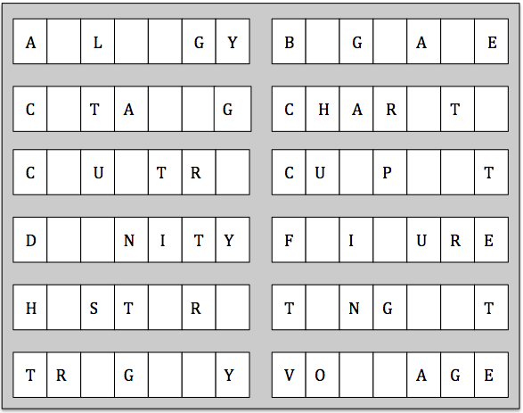

Figure 2. A Word completion task based on Smith & Tindell (1997).
Memorization of a short word list is an unchallenging task, but as you have probably already guessed, this was merely a distractor designed to interfere with your performance on the completion task that followed. And interfere it most certainly does: for as your mind searches for a word that matches A-something-L-something-something-GY, there’s that similar-looking word from the original list, ANALOGY, jumping up and down for your attention. On closer analysis, though, this seductive near-match will simply not fit in the available spaces, and so you are forced to move on. However, alternate candidates are now that much harder to identify while your mind remains fixated on that tantalizing near-miss. Because “ANALOGY” was primed by the recent memory task, it sits at the top of the list when our automatized retrieval processes go looking for a solution to this new but familiar-looking completion problem. The harder we try to disregard “ANALOGY”, the more stubbornly primed it remains, refusing to budge from memory where it serves to block the retrieval of a more appropriate solution. Smith and Tindell succinctly capture this somewhat perverse state of affairs within the title of their paper: “Memory blocks in word fragment completion [are] caused by involuntary retrieval of orthographically similar primes.”
Priming is an automatic cueing process in which one stimulus unconsciously prepares the mind for the associated stimuli that follow. As such, priming is one of the mind’s principal mechanisms for allowing the particulars of a given context to subtly influence our approach to a problem. Priming is the reason that the word “cats” is likely to make us think of dogs, “salt” is likely to make us think of pepper, and “cloud” or “storm” prepares us for rain. Priming lends fluidity to our actions by cueing up the information that our minds are likely to need next, in much the same way that a CPU pre-fetches from memory the instructions that a program is most likely to execute next. But Smith and Tindell’s word-fragment completion task highlights the blocking action of a misleading prime, showing that such primes can instead act as a memory block that stubbornly hinders the retrieval of more appropriate information. In contrast, when a positive priming stimulus cues up information that is truly salient to a problem, valid solutions can be so much easier to find. Had our initial word list contained the positive primes like ALLERGIC, CATALOGUE, DIGNIFIED and COUNTRIES, our minds would have been far better prepared to find the completions of Figure 3.
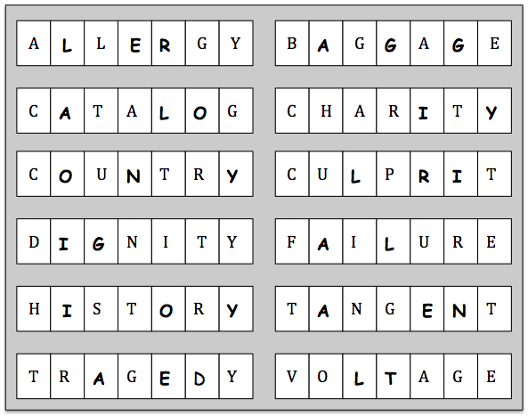
Figure 3. A viable solution to the word completion task in Figure 2. None of the words on the original memorization list offers a valid completion.
In a related paper, Smith notes the baleful effects of automatic priming on the creative processes. Not only do negative primes hinder our ability to explore alternative candidates, but positive primes can also lead to us to fixate on existing solutions that are proven to work, or on our own initial solutions that show some merit yet which may need to be substantially revised or rejected. Smith hypothesizes that the automatized, information-processing architecture of the mind – which insists on the involuntary retrieval of potential memory blocks – is also the reason why so many brainstorming sessions start strong but soon fizzle out. Psychologists have observed output interference in free recall tests of words, in which words from a list are memorized and later recalled in any order. Since the act of retrieval inevitably primes a word and adds to its perceived salience, any word that is initially recalled has a higher probability of being recalled again than other words on the list. This recall inhibition effect, called part-set cueing inhibition, can also explain stagnation effects in brainstorming sessions. Brainstormers are required to withhold judgment on the ideas that are generated in a session, but even the act of suggesting a weak or unworkable idea also makes it more likely that this idea, or a close variant, will be suggested again and again. Brainstorming strives to pool the collective insights of a group, but it also mutualizes the risks of the group collectively falling into a rut.

Systematizing Creativity: A Tale of Two Velocities
In his masterful book “Thinking, fast and slow”, psychologist Daniel Kahneman employs an Aesop-like simplicity to portray the workings of the mind as a story of two conflicting protagonists, System 1 and System 2. System 1 is a hare, swift and responsive, always twitching and always on, and always ready for a race. Automatic priming and the involuntary retrieval of information are a key feature of System 1’s operation. When these automatic processes work to our advantage, it is System 1 that greases the rails for our lightening-fast intuitions. And when these processes work against us, causing us to fixate on distracting near-misses, it is System 1 that makes these distractions so hard to ignore. For instance, if I tell you that I bought a bat and ball at a jumble sale for $1.10, and then add that the bat cost $1 more than the ball, System 1 will likely tempt you with the seductive but erroneous conclusion that the ball cost 10 cents. After all, both $1 and 10 cents have been primed in the specification of the puzzle, so this seems an obvious division of costs. By comparison, System 2 is a tortoise, sluggish and analytical, easily tired and slow to engage, but nonetheless capable of deep engagement when it does decide to act. It is System 2 that reveals the inadequacy of the $1 and 10 cents solution to the bat and ball puzzle (since $1 ≠ $1 + 10 cents), and guides us to the correct answer of $1.05 and 5 cents instead.
But the Wegman’s cake of Figure 1 demonstrates the inherent laziness of System 2, showing us what happens when we over-rely on the autopilot provided by System 1. In the race to conclusions, System 1 invariably beats System 2 to the line, but its conclusions are often less than reliable. We need to engage the mechanisms of System 2 whenever System 1 jumps too quickly to its conclusions and leaves us feeling stymied by a problem. Yet, though System 2 is often required to clean up after System 1, System 2 has very little direct control over System 1: it can step in to repair the latter’s misconceptions, but it has very little ability to prevent those misconceptions from occurring in the first place. For as psychologists like Steve Smith have shown, attempts by System 2 to override the erroneous conclusions of System 1 often cause these conclusions to become even more embedded in our thinking. Nonetheless, the occasional failings of System 1 should be a cause of celebration, not concern. Comedians use their understanding of System 1’s shortcomings – no doubt derived from their own first-hand experiences – to entertainingly exploit these shortcomings in the System 1 processes of other people, in the form of jokes. A well-crafted punch line reveals the inherent conflict of System 1 and 2. Without this conflict, there can be no jokes. Moreover, a really good joke – like good art – spurs us to fully engage System 2 so we might derive a deeper understanding of a situation. But we can be more provocative still: without the essential conflict between Systems 1 and 2, which is essentially a tale of two velocities, there can be no creativity, or at least very little of the kind of innovation that appears non-obvious before the fact (using System 1) but surprisingly obvious after the fact (using System 2).
Because of the ease with which humans fall into ruts or find themselves thwarted by memory blocks, theorists and practitioners have long sought to systematize the processes of creative thinking. Approaches vary in their specific emphases, yet each can be understood as an attempt to place the free-ranging associative abilities of System 1 under the disciplined control of System 2. Ironically, the instinctive automatization of System 1 is tamed by imposing upon it the conscious execution of an algorithm, which the disciplined thinker executes in a step-by-step fashion with perhaps the benefit of pencil and paper. It is not entirely surprising then that these attempts at systematization have much in common with algorithmic attempts to imbue computers with creative abilities. After all, an understanding of the mechanisms of creative thought can be an excellent guide to the construction of creative mechanisms.
The first step toward systematization is the recognition that creative people employ a variety of different strategies to develop new ideas. These strategies can be applied in isolation or in combination, either once off or recursively, for the exploration of the space of potential ideas. A comprehensive set of creative strategies, expressed as a checklist of questions to ask oneself when seeking to generate new ideas, was suggested by Alex F. Osborne – the inventor of “brainstorming”– in his 1963 book, “Applied Imagination”. The title of Osborne’s book suggests an appealing metaphor, in which the creative imagination is viewed as an undisciplined schoolboy, whose report card might well read “shows promise, but is too easily distracted. He really needs to apply himself more.”

1. Adapt?
a. Are there new ways to use this as is? b. Other uses if modified?

2. Modify?
a. New twist? b. Change meaning? c. Change color? d. Change motion?
e. Change sound? f. Change odor? g. Change form? h. Change shape?
i. Other changes?

3. Magnify?
a. What to add? b. More time? c. Greater frequency?
d. Stronger? e. Higher? f. Longer?
g. Thicker? h. Extra value? i. New ingredient?
j. Duplicate? k. Multiply? l. Exaggerate?

4. Minify?
- What to subtract? b. Smaller? c. Condensed?
- Lower? e. Shorter? f. Lighter?
- Omit? h. Streamline? i. Split up? j. Understate?

5. Substitute?
a. Who else instead? b. What else instead? c. Other ingredient?
d. Other material? e. Other process? f. Other power source?
g. Other place? h. Other approach? i. Other tone of voice?

6. Rearrange?
a. Interchange parts? b. Other pattern? c. Other layout?
d. Other sequence? e. Transpose cause & effect?
f. Change pace? g. Change schedule?

7. Reverse?
a. Transpose positive & negative? b. How about opposites?
c. Turn it backward? d. Upside down?
e. Reverse roles? f. Turn tables?

8. Combine?
a. Blend? b. Alloy? c. Assortment? d. Ensemble?
e. Combine units? f. Combine purposes? g. Combine appeals? h. Combine ideas
Osborne’s checklist serves as a creative mentor in crib-sheet form, prompting the stymied innovator with a range of questions for escaping ruts and sidestepping memory blocks. So you think you’ve tried everything to no avail? Well, have you considered playing replacing one part with another (5a … 5f) or playing around with the arrangement of the parts you already have (6a, 6e)? How about combining a number of previous successes (8a … 8d), or viewing the problem from a radically different perspective (7a … 7f)? How about simply jettisoning some of your requirements (4a, 4g)? These questions encourage a creator to engage the deliberative, analytical and reflective modes of thought that are hallmarks of System 2 processing. By talking through a problem and consciously posing these questions to oneself (or to a collaborative group), a creator will simultaneously activate the reflexive thought processes that are characteristic of System 1. Possible solutions that are suggested by System 1, via the automatic recall of primed concepts from memory, will then form the basis for further reflective thought via further self-questioning. In other words, Osborne’s checklist – like any other division of the creative process into specific steps, strategies or sub-processes – provides a schematic structure for harnessing the best qualities of Systems 1 and 2. Importantly, System 1 is still free to perform associative retrieval, but its operation is subservient to the goals of System 2.
In computational terms, Osborne’s checklist is a suite of operators for manipulating our mental representation of an idea, so that we can explore the conceptual space around that idea. To see these operators at work, or to at least perceive post-hoc the application of these operators in existing innovations, we can look to the patent archives to see how past inventors have generated viable new ideas from a well-established starting point. Any idea domain will do, but we consider here the domain of word games. This is an evergreen area of innovation, which continues to thrive in the age of games consoles and smartphones; indeed, word games provide some of the most popular apps for smartphones. This domain is also interesting due to the existence of a powerful source of priming, and perhaps blocking, in the always popular Scrabble. The rules and game elements of Scrabble are a fertile basis for innovative variation, but the market dominance of the game is just as likely to be a source of creative ruts and memory blocks. To consider word games that openly acknowledge a similarity to Scrabble, we can search the U.S. patent archives (www.USPTO.gov) for patents that contain the terms “word game” AND “Scrabble”. In the 70 or so patents that are retrieved, we see a wide range of word games that build upon Scrabble using one or more operators on Osborne’s checklist. Many use the Magnify strategy to add some new wrinkle to an existing variant of the game. For example, giant tiles allow us to create a garden variant of Scrabble in which one’s lawn serves as a game board (3g, 3l, and other place, 5g), while the addition of connectors to link these tiles together (3i) supports an aquatic version of the game, so that chatty swimmers can enjoy Scrabble while splashing in the pool.
Blending of different game formats – specifically, a word game with a non-word game – is a popular strategy in the development of patented word games. To make the new format viable, such blends often necessitate the substitution of existing game elements (5), and/or the addition of new elements from the second input to the blend (3). For instance, U.S. patent 7,497,778 describes a blend of a word-game and a lottery (8a, 8g), in which players buy tickets marked with words rather than numbers (other ingredient, 5c). The lottery comes into play with the drawing of random letters (rather than the conventional numbers, again 5c), so that the winning ticket is the one whose words contain the most letters from the draw. U.S. patent 6,761,642 describes a Scrabble-like game that is played on a billiards table with balls marked with letters (5c), in which words are formed by using a billiard cue to sink letter-balls in orthographic sequence. U.S. patent 6,460,855 describes a blend of Scrabble and chess, in which it is the squares of the checkerboard – rather than the movable game pieces – that are marked with letters (6c, other layout, and 7e, reverse roles). Players form words by moving the chess-like game pieces into the appropriate letter squares. U.S. patent 6,224,057 appears to combine Scrabble and Trivial Pursuit, in which players answer questions and are then given the chance to construct a list of words from the letters of the correct answer. U.S. patent 5,702,105 describes a blend of Scrabble and Ludo, in which players form words on a game board in such a way as to progress from the bottom to the top of the board. It seems that almost any table game can be blended with Scrabble, albeit with varying success.
Perhaps the most protean Scrabble variation is described in U.S. patent 4,333,656. Two decks of playing cards are combined to form a double deck of 104 cards (3j, duplicate), which is just about the same number of letter tiles stored in a Scrabble bag. Each card is marked with a letter and a numeric value, where the value – as in Scrabble – is an inverse function of the letter’s frequency in English. The deck can thus be used to play the orthographic equivalent of poker, or other games in the same family, in which players attempt to form the highest-scoring words they can from the hands they are dealt. Hands can be scored by summing letter values in much the same way as in Scrabble, and the deck also contains a small number of blank wildcards that can substitute for any letter. This blend of Scrabble and poker obviates the need for a board (4a, what to subtract?), while importing some of the best elements of the latter (2a, new twist), such as betting and bluffing. For as in poker, players may pretend to have an excellent hand, bet accordingly, and only reveal their bluff when opponents pay to “see” their letters. This blend of Scrabble and poker is also highly productive, and supports many variations of the latter, such as Texas Hold ‘em. In this poker variant, a river of communal cards is gradually upturned in the middle of the table, while players – who each hold a number of private cards “in the hole” – increase their bets. Each player forms the best hand they can by combining cards from their private stash and the communal store. The exciting poker dynamic of betting and bluffing is preserved whether one’s hand is “oxygen” or a full house of aces over queens.
Even the simplest variations are patentable if they are non-obvious, but there is rarely such a thing as a non-obvious variation that can be implemented with a single change. Due to the subtle interdependence of parts and features, one change – whether an addition, a magnification, or a removal – almost always necessitates others. Each of the changes described in the patents above thus require a period of reflection and engagement on the part of the inventor, using the deliberative processes of System 2, if these changes are to be successfully integrated into the whole. But note how each change also crucially depends on System 1 to suggest the elements of the mental representation to which the change will apply. Thus, it is the associative architecture of System 1 that allows us to focus on the salient attributes of a concept when we consider a magnification (3) or minification (4) of qualities, or a substitution (5) or rearrangement (6) of parts. Osborne’s checklist treats these operations as black boxes, so we must turn to a more fine-grained analysis of parts and attributes if we are to apply the discipline of System 2 at an even deeper level of analysis.
Attribute analysis is a widely taught technique for creative ideation that can help a thinker to see past the immediate judgments of System 1, so that System 2 can find alternative perspectives on a complex object or situation. In its efforts to grease the rails of conventional thought, System 1 actively primes those categorizations of an object that are most relevant to how it is typically used. This priming effect can inhibit our ability to perceive alternate viewpoints on an object, and block our attempts to use it in unconventional ways. A user of attribute analysis begins by listing its typical attributes, whether or not they appear essential or even salient to the object’s function. For any given attribute, the thinker makes a list of other objects that typically exhibit this quality. One can then consider whether the functions or behaviors of these other objects – which share one or more attributes with our original starting point – might also apply to that original object. As such, attribute analysis formalizes a process that people already use automatically when they react creatively to a situation, but it puts this process under the mostly conscious control of System 2. For instance, attribute analysis is instinctively used when a woman uses lipstick to write a note on a mirror, or when a handyman uses a coin to ease off the lid on a tin of paint, or when a programmer uses a web-email account as a backup store for important documents, or when a homeowner reaches for a golf club or a poker when he hears suspicious sounds coming from downstairs in the dead of night. When unable or unwilling to use the object that typically provides us with the attribute X, such as ink for writing or a weapon for self-defense, another object with X-ness may serve the same function in a pinch (lipstick, a breadknife, etc.).
In fact, the principle underpinning attribute analysis is so intuitive, the same principle finds its way into various computational models of creative thought. In a paper from 1989 titled “Marker Passing over Microfeatures”, James Hendler describes an interesting design challenge for an automated system. If one buys a butcher’s cleaver while on vacation in China, an automated check at the airport is very likely to recognize this object as a potential weapon, presumably because sharp knives and cleavers are on a standard list of prohibited objects. So a security system that flags this possible danger is doing the right thing, even if the passenger has only the most noble culinary motives for carrying a potential weapon onto a plane. Now suppose one instead buys an ornate letter opener while holidaying in Egypt: though this object has the potential to be used as a stabbing weapon, it is very unlikely to be recognized as a threat by a security system that relies on a list – even a long list – of proscribed objects. Instead, we would hope that any automated security check would perform a basic attribute analysis of novel objects, and thus recognize the possibility of using an antique desk ornament as an alternative to a knife. Hendler wrote his paper in more innocent times, before air travelers had to worry about terrorists hiding explosives in their underpants, yet his example is painfully prescient: human security guards failed to recognize the potential uses of box openers as lethal weapons when the 9/11 terrorists boarded their planes in 2001. While many cumulative mistakes contributed to the tragedy of 9/11, one was surely an over-reliance on System 1 over the mentally-demanding engagement of System 2.
To promote a deeper engagement with problems in science and society, the Caltech astronomer Fritz Zwicky vigorously championed a more structured and comprehensive form of attribute analysis called Morphological Analysis. The word “champion” is really quite apt here, for Zwicky even created a foundation to promote and teach his analytical approach, one that has survived his death. In language, the morpheme is the smallest carrier of meaning, and words derive both their form and their meaning from a specific sequence of morphemes (such as un-know-able). Good writers show an intuitive understanding of the morphological possibilities of language, and appreciate the often dramatic effects of swapping out one morpheme for another in the same semantic field. For example, consider Woody Allen’s neurosis that “I am at two with nature”, or his attribution of marital problems to the fact that “I put my wife under a pedestal.” More abstractly, the “morphemes” of a problem domain likewise serve as the combinatorial units of meaning from which new solutions can be composed. The first step of morphological analysis then, in the Zwicky sense, is the identification of the morphemes that can combine to form a new solution. So if, for instance, our goal is to invent a new mode of transport, we might first identify a set of morphemes to encode the attributes of scale (e.g. individual, small, massive), power source (e.g. oil, wind, solar), passenger type (e.g. commuter, tourist) and medium (e.g. air, road, rail, sea). A candidate solution could then be formed by selecting one morpheme for each dimension, to produce attribute combinations like massive-solar-commuter-rail (e.g. a mass-transit solar-powered rail system for commuters, such as a monorail in an always sunny country).
So to invent a new game, we should instead draw our stock of morphemes from the combined elements of Scrabble, Poker, Trivial Pursuit, Ludo, and any other game we can think of. Imagine yourself emptying a bunch of games with their assorted paraphernalia onto the floor, and then sifting through the resulting mess to thematically group elements and rules across games. Unlike basic attribute analysis, morphological analysis aims to capture the recombinant possibilities of a whole domain at once, by viewing each solution as a multi-dimensional structure in which alternate attribute values can be chosen for each dimension. Analysis begins then with the assignment of each attribute to a single dimension, and by assigning each dimension to a column in a tabular structure called a Zwicky box. Each cell in a Zwicky box holds one attribute in one specific dimension, while other cells in the same column hold alternate values for that dimension. Just as a 3D object must be specified with spatial coordinates on all three dimensions, a morphological solution must specify a morphemic attribute for each of N dimensions, as selected from the N columns of the Zwicky box. The trick, of course, is in how one selects the dimensions and attributes for a domain. An incisive representation will carve up a domain in a way that allows viable solutions to be composed from attributes that combine freely with others. A clumsy partitioning, however, will yield a poor harvest of ill-fated combinations.
Table I presents a morphological analysis of the games domain that uses just five dimensions: the type of board used, if any; the key resource that is acquired or allocated; the objective of the game; the dominant strategy employed; and the game’s source of randomness, if any. According to Table 1 then, Scrabble is a game played with jumbled letter tiles on a grid, in which the goal is to achieve the biggest (cumulative) score by forming words. Note how this representation is highly under-specified, since a selection of context-free attributes is not in itself a solution, merely the raw material of one that still needs to be molded and filled in by subsequent interpretation. Thus, our interpretation above assumes that it is the letter tiles that are jumbled, that only valid words are formed using these letters, and that scoring is cumulative across these words. These elements only make sense in the context of System 2’s ability to fill in the implicit gaps.
Board type | Resource | Objective | Strategy | Randomness
None | Playing Card | Progress most | Connect | None
Checkerboard | Stone | Finish first | Form words | Dice
Map | Building | Acquire most | Block | Spinner
Circuit | Army unit | Deplete most | Trade | Shuffle
Track | Spell | Cover most | Encircle | Jumble
Grid | Play Money | Biggest score | Alliance | Blindfold
Maze | Counter | Last longest | Capture | Coin toss
Path | Letter tile | Kill opponent | Bluff | Timer
Honeycomb | Hit Points | Find treasure | Form patterns | Short Straw
Table 1. A simple 5-dimension Zwicky box for the domain of games. Highlighted cells correspond to the attributes of Scrabble.
By alternating the attributes chosen from each column, we can “read off” different solutions from a Zwicky box. For instance, we might play Scrabble on a checkerboard, or on a map, or on a track. If played on a map, the goal might be Cover most of the map (Scrabble as a territorial game, like Go); if played on a track, the goal might be Finish first or Progress Most (Scrabble as a race to a finish line). If randomness is provide by dice, perhaps the dice are marked with letters, so that letter tiles can be replaced with counters (e.g. players might roll dice and make words from the upturned faces, to advance their counters on the game board). Or we might play chess with playing cards instead of military pieces. If plastic bases are used to hold each card in an upright position on the board, then different cards (King, Queen, etc.) can take the place of chess pieces of the corresponding rank. The fact that playing cards are two-sided also allows a player to turn the face of each card away from an opponent’s gaze, so that one can only infer the rank of a card from how an opponent moves it on the board. These possibilities show that a given attribute sequence is a starting point and not an end-point for the elaboration of a solution, and significant engagement by System 2 is yet demanded from a problem solver.
Still, looking at Table 1 it is hard not to feel we have done a real disservice to Scrabble with this rather coarse representation, and that more nuance is needed in the form of additional dimensions (such as major skill needed, major constraint imposed, or bonus elements, to suggest just three). Yet as we add columns to a Zwicky box, or add more attributes to each column, the number of combinations that can be “read off” the box grows with alarming speed: N dimensions of M attributes yields a space of MN potential solutions. Zwicky saw his morphological approach to solution generation as a form of “totality research”, in which one avoids ruts and blocks by removing biases and allowing all possible solutions to a problem to emerge. However, if N and M are not kept small, the totality of a morphological space can often be much too large for a human analyst to manage.
To manage the space of solutions implied by a Zwicky box, morphological analysis applies a second phase of analysis called Cross-Consistency Assessment (CCA). CCA recognizes that not every cross-dimensional pairing of attributes is sensible or even possible, and so performs a pairwise analysis of all attributes from different dimensions to determine which pairings are viable and which are not. For instance, Form words + Letter tiles is clearly viable, because words can be formed from the letters on the tiles (and Scrabble is proof of this viability). However, Form words and Kill Opponent seems an unworkable combination, and so any potential solution that uses this pairing can be discarded as unworkable too. In fact, any possible solution that contains a pairing of morphemes that CCA frowns upon in discarded, so that only viable solutions pass muster for further consideration and analysis. Zwicky referred to this means of shrinking the space of possible solutions to better approximate the space of viable solutions as his “principle of contradiction and reduction.” In effect, CCA uses an analysis of the consistency of N2M2 - N2M attribute pairings to filter a space of MN attribute combinations. Since the latter grows much faster for an increasing N than the former, this effort is a wise use of one’s time. Nonetheless, as demonstrated in our earlier patent survey, a flexible mindset will often find ways of making the oddest attribute pairs work well together. For instance, we can Form Words with Army Units on a Checkerboard if we mark the squares (rather than the pieces that sit on them) with the letters needed to form words (U.S. patent 6,460,855).
Attribute analysis and morphological analysis each define a space of combinatorial possibilities in which a problem solver must systematically navigate to find creative solutions. Good representations open up new avenues of search in a space, while poor representations shut them down. Ironically, these techniques ask humans to mimic the kind of automated search techniques that are the sine qua non of good old-fashioned AI, and make much the same representational demands on our modeling of a problem. But since each taps into the same basic intuitions about creativity, each may have much to add to our understanding of the other. We shall return shortly to a consideration of how AI can be used to automate the application of morphological analysis. For now, let’s further explore this intriguing symmetry between techniques for systematizing creativity in humans and algorithms for automating creativity in machines.
* * *
Hendler’s model used marker passing, a form of spreading activation that psychologists have used to explain the workings of priming in System I. An activated concept spreads some of its priming activation onto associated concepts, which in turn spread some of their cumulative activation onto their associates, and so on, until the activation signal is too weak to spread further. Inspired by Hendler’s approach, the Sapper model of Veale and Keane also uses spreading activation, again in combination with a form of attribute analysis, to recognize complex analogical mappings between two conceptual structures. If attribute analysis indicates that A and B share one or more attributes and are therefore potentially substitutable (e.g. 5a … 5i in Osborne’s checklist), Sapper builds on this part-level observation to suggest the higher-level substitutions that may be required for a consistent analogy or blend (8a). Sapper models the basic principle of attribute analysis via its triangulation rule, so named because an object A with an attribute Q that is also possessed by B is most naturally visualized using the triangulation pattern A-Q-B in Figure 4.
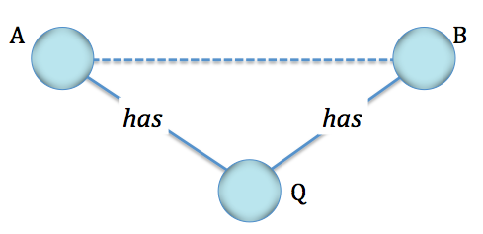
Figure 4. Schematic structure of Sapper’s Triangulation rule. Concept A has the attribute Q, which also happens to be an attribute of concept B. Hence A and B are relatable via Q, and perhaps substitutable because of Q.
Recall that attribute analysis is used to find pathways between otherwise unconnected concepts that share common attributes, so that these pathways might guide operations like substitution (5) and combination (8). Sapper is so-named because it lays down bridges between concepts that are identified by attribute analysis as worthy of connection. If A and B share a number of different attributes, then this lends even more support to the possibility that A and B are comparable, and perhaps even interchangeable in a creative context. Figure 5 shows the specific attribute analysis that supports Sapper’s triangulation of the letter tiles used in Scrabble and the playing cards used in a game of poker. Sapper connects these concepts with a bridge (visualized as a dashed line in Figures 4 and 5) that serves as a foundation for the structural analysis to follow.
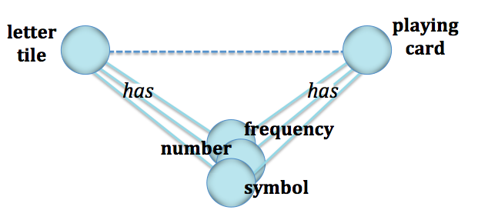
Figure 5. The Triangulation rule as applied to the concepts letter tile and playing card, which share the attributes has frequency, has number and has symbol.
Sapper also applies a squaring rule that allows it to build bridges between concepts that do not have attributes in common, that is, between concepts that are not connectable by standard attribute analysis. The intuition here is that two concepts are analogically similar when they relate in precisely the same way to two other concepts that have already been bridged by Sapper via either the triangulation rule or the squaring rule. The schematic form of the squaring rule is illustrated in Figure 6.
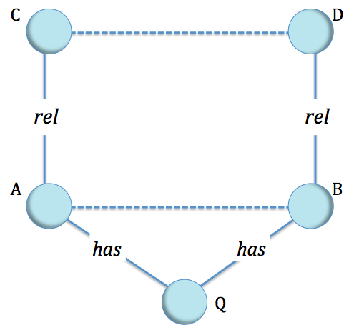
Figure 6. Schematic structure of Sapper’s Squaring rule. Concepts A and B are literally similar because they share the attribute Q. In turn, concept C relates to concept A via the same relationship rel as concept D to B. Hence a degree of analogical similarity is also perceived between C and D.
The application of Sapper’s squaring rule to the newly formed bridge in Figure 5 leads to the recognition of analogical similarity between the letter bag used in Scrabble and the deck of cards used in poker. As shown in Figure 7, Sapper constructs a bridge between letter bag and deck of cards to reflect this insight.
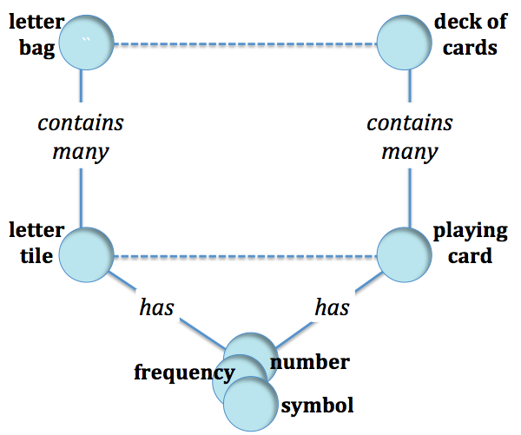
Figure 7. The Squaring rule builds on the similarity of letter tile and playing card. Since letter bag contains many of the former and deck of cards contains many of the latter, these two concepts are also similar, analogically.
The letter racks in Scrabble are filled and replenished using a random selection of letters from the communal letter bag, which resembles the way in which each hand of cards is dealt from the communal deck in poker. More formally, the letter rack relates to letter bag via the same relationship – let’s call it random selection of – as hand of cards to deck of cards, so the squaring rule builds on the bridge added in Figure 7 to construct the parallel bridge between letter rack and letter bag shown in Figure 8. The squaring rule views analogy as a form of conceptual parallelism, so it seeks to add parallelograms of new connections to the conceptual representation of a domain, such as the game domain we consider here. Note also that two concepts can be bridged using both the squaring rule and the triangulation rule at the same time. Suppose that letter bag and deck of cards share the attribute communal. In this case they would be bridged using both triangulation (i.e., standard attribute analysis) and squaring.
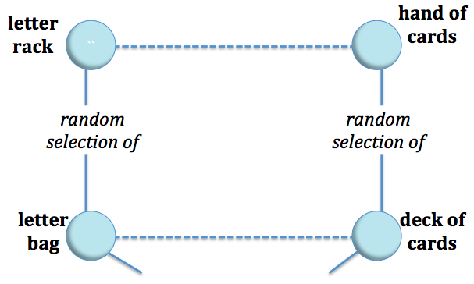
Figure 8. The Squaring rule builds on the analogical similarity of letter bag and deck of cards.
Squaring can be applied whenever a new bridge is created between a pair of concepts. In this way, bridges act as foundations for the construction of even more bridges, so that a ripple-effect is observed in our conceptual representation of a domain: as more concepts are bridged, even more become potentially bridgeable. Figure 9, for instance, illustrates the use of squaring to build a new bridge on top of the recently bridged pairing of letter rack and hand of cards. Since words are formed in Scrabble via a selection of letters from one’s rack, and a poker hand is formed via a selection from one’s hand of cards, the concepts valid word and poker hand are thus seen as counterparts by the squaring rule.
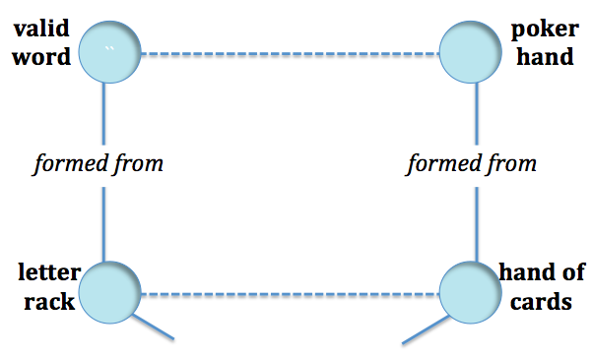
Figure 9. The Squaring rule builds on the similarity of letter rack and hand of cards to detect an analogical similarity between Scrabble words and poker hands.
Sapper is a computational model that is designed to work automatically over a computer’s formal representation of a domain, such as the domain of games. It uses spreading activation to prime the initial starting point of its investigation, such as Scrabble, and then allows this activation to spread across relational links to associated concepts, such as letter bag, letter rack, letter tile and so on. Wherever activation spreads, Sapper applies the basic principle of attribute analysis, as implemented via its triangulation rule. When this rule creates a new bridge between an activated concept and a concept with which it shares one or more attributes, such as between letter tile to playing card, activation becomes free to flow across this bridge, to activate previously unreachable concepts in the games domain. Moreover, whenever Sapper constructs a new bridge, it uses the squaring rule to find other concept pairs that are analogically similar by virtue of having parallel relationships to the newly-bridged concepts. Activation is free to flow across these bridges also, to reach analogically-relevant areas of the domain that would not otherwise be reachable using standard attribute analysis.
In the case of Scrabble, we can expect successive applications of the triangulation and squaring rules to construct a number of bridges from Scrabble itself, to reach across the games domain to other game concepts that could well serve as useful analogies. Those analogous concepts, such as poker, will have cumulative levels of activation that are indicative of the number of bridges that activation was able to flow across to reach them from Scrabble. Since the bridges in Figure 5, 7, 8 and 9 provide ample opportunity for activation to flow from Scrabble to poker, the latter strongly presents itself as a highly-activated analogy for the former. Moreover, the bridges that Sapper constructed to connect Scrabble-related concepts to poker-related concepts will now indicate the most sensible pairings of ideas to which to apply Osborne’s checklist of substitution and combination operators, to construct a new amalgam of Poker and Scrabble.
* * *
As an automated computational model, Sapper suffers from a flaw that afflicts all AI models of creative reasoning – including Hendler’s marker passing model – from the 1950s to the early years of this millennium. This weakness, ironically, is a reliance on hand-made representations of a conceptual domain. For whenever Sapper performs attribute analysis on a concept such as letter tile, it relies on a formal representation of the domain in which the attributes of letter tiles and playing cards and chess pieces and game boards have all been comprehensively identified and encoded in advance. Sapper does not possess the powers of introspection to enumerate these attributes for itself, nor does it possess the ability to encode for itself the relational linkages that are needed so that it can apply the squaring rule in Figures 7, 8 and 9. Because Sapper needs to be given the relevant concepts and relations that define each new domain in advance, it is a semi-automatic model, and not a fully-automatic model, of open-domain analogical discovery. Once a human user provides a thoughtfully hand-crafted model of a domain like the games domain, Sapper can then automatically and efficiently explore many different applications of its triangulation and squaring rules to suggest analogies, combinations, substitutions and blends in this domain that might not otherwise have been recognized by the user without Sapper.
Of course, some systems are specifically designed to operate in specific domains, and insofar as these systems are never expected to wander outside their realms of inquiry, these systems can be considered fully autonomous in that domain. Autonomy is a matter of perspective: we don’t think of a goldfish as any less autonomous because we provide the tank it lives in, the water it swims in, or the food it eats. Cameron Browne’s Ludi system, which is designed to explore the space of abstract board games, demonstrates the validity of this narrow perspective. Because Ludi’s inventions are abstract games that make no reference to real-world concepts, its formally defined knowledge of this domain is ample for its needs. Ludi does not seek to discover useful analogies between existing games, but actually attempts to invent new games of its own, rules and all. One especially playable game that Ludi has invented is published by the games company Nestor Games, which markets the game under the name Javalath. In this game, which bears superficial similarities to Go-Moku and Connect Four, two turn-taking players (using white and black game stones respectively) aim to create an unbroken line of four of their stones on a hexagonal board. But Ludi invents a clever wrinkle: players are not allowed to make 4-in-a-line by first making 3-in-a-line. A winning line of four stones must be constructed from both ends, and such attempts give rise to a number of fascinating blocking strategies.
Though Ludi’s closed domain is small, it is a highly productive one, and Ludi exploits a computer’s processing power to explore its many nooks and crannies. In contrast, open-domain systems like Sapper which are driven by a small number of clear-cut principles – such as the triangulation rule (essentially attribute analysis by another name) and the squaring rule (a structured means of extrapolating the insights yielded by lower-level attribute analysis) – can meaningfully be employed both by machines and humans. Such systems demonstrate the inherent symmetry between, on the one hand, the techniques that are taught to humans for systematizing their personal creativity, and on the other, the techniques that are formally and algorithmically implemented within a machine so as to enable computers to exhibit some measure of their own creativity. This symmetry means that, when the algorithms are simple and elegant, a principle-driven system like Sapper can be used both as a computational model for machines and as an advanced form of attribute analysis for humans, which people can apply with the aid of pencil and paper to systematically guide their own creativity.
Yet why use pencil and paper when a computer can be used to provide a more sophisticated set of tools? The step-by-step, algorithm-like discipline of systematic approaches to the fostering of human creativity – such as attribute analysis and morphological analysis – makes it feasible to turn these mental tools into actual software tools. We are not talking here about computational models of machine creativity, or even computational models of human creativity, but of basic software support for the techniques that are commonly marketed as a means to nurture one’s decision-making and ideation skills. For instance, a variety of software packages exist to enable people to create Zwicky boxes, decision matrixes, mind maps and so on. It’s not unrealistic to believe that as such tools are endowed with incrementally more ambitious features they will gradually shoulder more of the creative burden, so that work on tool development and research in computational modeling will ultimately converge at a middle-ground position we might call hybrid creativity or co-creation.
What kind of incremental additions might bring these software tools closer to the point of co-creation, a point at which an inventor feels compelled to admit that the creative paternity of a new idea should be shared with the software? To begin with, smarter software can make a real contribution to the hardest part of problem definition, as seen in approaches like morphological analysis: coming up with a clear-headed representation of a problem domain, by suggesting an incisive dissection of that domain into the dimensions and attributes that best support the generation of viable new solutions. This is much more than a matter of simply enumerating dimensions and their possible attributes, though even that is itself a significant challenge for computers lacking in world knowledge. A muddle-headed dissection will assign non-competing attributes to the same dimension and falsely force us to choose between them, and conversely assign competing attributes to different dimensions, where they simply increase our likelihood of generating non-viable solutions with irresolvable internal conflicts.
An inescapable irony of these explicitly representational approaches is that one is required to deconstruct one’s knowledge of a domain so that it can be re-assembled in the form of solutions that our mental blocks and ruts might otherwise have hidden from view. However, the resulting representation, such as the Zwicky box of Table 1, is just as likely to create blocks and ruts of its own. Since different thinkers are likely to deconstruct a complex domain in different ways, using different sets of dimensions and attributes, one person may well generate solutions that are not possible with another person’s representation. A flawed analysis can thus limit our perspectives on a domain just as surely as the biases and preconceptions that morphological analysis is designed to overcome. But smart software tools can take representational analysis to the meta-level, where the object of manipulation is not the domain itself, but the representation of the domain. A toolset that is used by many different users for a diverse set of domains can pool its analyses of those domains, so that with enough experience, a tool can suggest alternative representations to the ones we ourselves have created. This re-representation of a domain sometimes leads to what creativity theorists call transformational creativity: a new perspective on a domain that seems to throw away the rulebook and start afresh. This is a rare phenomenon, and perhaps even an over-rated one at that. But the re-representation of a domain need not be transformational to be useful, to shake out solutions that were not previously possible with a different representation.
No single resource contains all of the knowledge that a computer needs to make these kinds of representational decisions in a wide-ranging, open-domain fashion. However, many small-scale resources do specify some of the necessary perspectives, whether implicitly or explicitly. If we can pool these many perspectives – which in isolation may be so limited as to be a real source of ruts and memory blocks – we can build the kind of richly-nuanced, multi-faceted resource with which our computers can flexibly model a conceptual domain. This diversity of resources is distributed across the World-Wide-Web, but we can gain targeted access to their collective wisdom using popular search engines like Google or Bing. Of course, this view of the Web as a source of wisdom, collective or otherwise, will raise eyebrows among those who are more inclined to see the Web as a source of noise and disinformation. Both views are partially correct, so any attempt to collect useful perspectives from the Web must aim to mine only from seams of consensus knowledge while avoiding pockets of spurious gas.
To mine a seam, we start at a nugget of genuine knowledge and feel our way from there to neighboring nuggets, all the while moving from one piece of valid knowledge to another. To identify a reliable starting point, we find a piece of presumed knowledge that satisfies multiple interlocking criteria of validity. For instance, we can look for a triple <A, B, C> for which text fragments of the following forms can be found on the Web:
“as B as [a|an|the] A” e.g. “as strategic as chess”
“B Cs such as A” e.g. “strategic games such as chess”
While the simile construction “as B as A” is often employed ironically (e.g. “as simple as Chinese mathematics”), the construction “B Cs such as A” is rarely put to ironic use. Thus, a triple <A, B, C> for which both of the above patterns can be found on the Web is highly likely to yield a salient, non-ironic association. The above phrases tell us (and our computers) that chess is typically perceived as strategic, and that it can be categorized as a representative member of the fine-grained category strategic game. In the same way, other texts on the Web support the perception of Scrabble as a social activity, while both chess and Scrabble are variously described as intellectual games and competitive activities.
These nuggets of common-sense knowledge allows us to reach out and find similar categorizations on the Web using a process called bootstrapping. Since we know that chess and Scrabble are intellectual games, the * in the following queries can only match other members of the same category:
“intellectual games such as * and chess”
“intellectual games such as * or chess”
“intellectual games such as * and Scrabble”
“intellectual games such as * or Scrabble”
These queries each use three bracketing anchors: intellectual, game, and a third “seed” member such as chess or Scrabble. Any match for * is thus highly unlikely to be ill-formed, since there is very little scope to misread the intent of a triple-anchored construction. As a result, we obtain reliable results where * is variously bound to “bridge”, “crossword”, “poker”, “checkers” and “backgammon”. These members can now be used to anchor new versions of our queries, and so bootstrapping is repeated until no new members can be identified in this way. Starting from some seed knowledge, bootstrapping doggedly seeks out the fullest membership of a fine-grained category, but it can also find new categories for a known member once it is acquired. We need only we shift the wildcard * to the category part of the query. For instance, results for the Web query “intellectual * such as chess” reveals that chess is variously categorized in different contexts as an intellectual pursuit, an intellectual activity, an intellectual skill and an intellectual challenge. So bootstrapping is an iterative process that can acquire both categories and their members from the Web, in a process that is akin to throwing a small stone into a very large pond: while the stone may only make the smallest of splashes, large ripples can spread out from its initial point of contact.
Fine-grained categorization allows us to deconstruct a complex idea into its component attributes, where the greater the number of perspectives we have on an idea, the more attributes that are yielded. Bootstrapping on the Web produces a large knowledge-base of diverse perspectives that can be deconstructed in this way, and so we use these to drive a simple but powerful Web application called Thesaurus Rex. Thesauri have always used an implicit form of attribute analysis to group words and concepts by apparent overlaps in meaning, but Thesaurus Rex makes these overlaps explicit, allowing a user to browse a large space of concepts by overtly using the principles of attribute analysis. For instance, Figure 10 shows the fine-grained categories that Thesaurus Rex finds for “chess”:
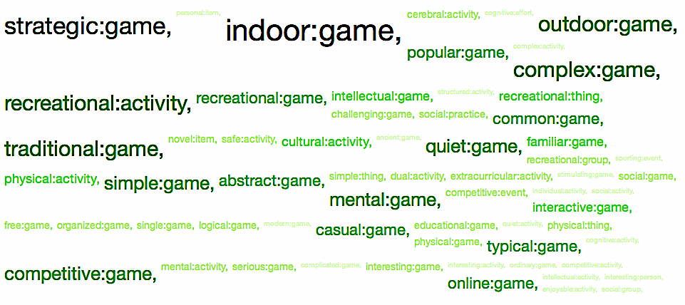
Figure 10. A sample of the bootstrapped perspectives on the concept Chess that are displayed by Thesaurus Rex in response to the input term “chess”.
Suppose a user clicks on the category mental game (right and down of centre in Figure 10). The most prominent members of this category – where prominence is a function of the number of times during bootstrapping that each member is placed into the category – are shown in the Thesaurus Rex output of Figure 11.
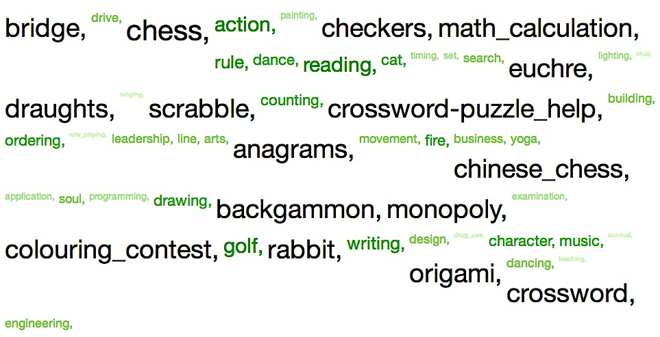
Figure 11. Prominent members of the category Mental Game in Thesaurus Rex.
Clicking on Scrabble in the cloud of Figure 11 now prompts Thesaurus Rex to show the most prominent fine-grained categorizations of this game (again based on how often Scrabble is re-discovered as a member of each category during the bootstrapping process). These categorizations of Scrabble as shown in Figure 12.
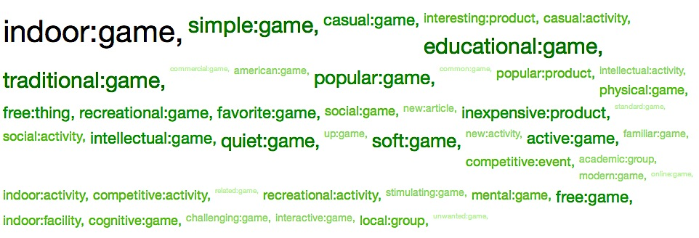
Figure 12. Fine-grained categories for Scrabble in Thesaurus Rex.
By navigating the space of ideas from an instance to its categories, and from a category to its instances, we can explore a domain using a combination of System 1 and System 2 processes, in the methodical manner advocated by attribute analysis. The process is not unlike surfing the Web, and can be just as immersive, though there is a crucial difference: every time we navigate from one concept to another, one aspect of the shared meaning that links these concepts is explicitly highlighted. Recall that attribute analysis shines a spotlight on just one attribute of a concept at a time, so as to encourage focused analysis around this specific attribute. In a similar fashion, computer-assisted attribute analysis caters to System 1’s love of wide-ranging free-association, but stops System 1 from running off in all directions, or from being overwhelmed from trying to consider too many possibilities at once. By keeping System 1 on a short leash, Thesaurus Rex encourages a methodical, step-by-step engagement of System 2 within a domain. But more than this, Thesaurus Rex supplements our System 1 intuitions about the attributes of a concept with the collected intuitions of the World-Wide-Web, insofar as it collects as diverse a set of attributes from as diverse a set of perspectives as it can find in the collected texts of the Web. Indeed, the hubbub of the Web might be viewed as a kind of collective imagination, one that throws up half-baked possibilities from many places at once. Smart tools can provide some of the discipline of System 2, to help turn these into fully-baked ideas.

Exceptional Machines
The celebration of all things creative encourages a laudable belief in human exceptionalism. This capacity to exceed expectations is often expressed relative to the banal regularity of machines, which are only considered a success when they actually meet our expectations. As Elbert Hubbard eloquently pitched it, “One machine can do the work of 50 ordinary men, but no machine can do the work of one extraordinary man”. Though sentiments like these can appear noble and inspiring, they antagonistically frame the debate as to how machines can best serve humans as a zero-sum opposition of two inimical rivals.
It is not always helpful to conceive of machines as replacements for human beings. A machine with even limited powers of ideation and self-criticism can be of tremendous use in helping a person reach that level of exceptionality to which creative people so often aspire. As argued earlier, the level of mechanical assistance may even be such that the machine itself deserves collaborative credit as an active participant and co-creator. Moreover, the ability to build co-creative machines is itself a hallmark of human exceptionalism, one that should no more be feared than the development of those mental tools and techniques that people learn to enhance their own creative powers. The perfectibility of human creative abilities is explicit in the use of these tools and techniques, and is thus implicit in the drive to make computers more creative by using algorithms based on the same insights and intuitions. In contrast, however, sentiments such as those expressed by Elbert Hubbard appear to argue against the perfectibility of human creativity, and suggest an altogether more elitist algebra of creative ability. Just do the math: if a machine can replace 50 ordinary men but not replace a single extraordinary man, then this extraordinary being must be worth more than 50 lesser mortals. This false dichotomy of ordinary versus extraordinary humans is no more helpful or necessary than that of humans versus machines. The goal of computational creativity can and should be seen then as much more than the construction of exceptional machines: it is the construction of machines that will allow people to go beyond the ordinary to create and do extraordinary things.
Though rule-bound systems seem unlikely candidates for these exceptional machines, we should be careful how we define the notion of a rule. In everyday life, rules elicit as much suspicion as automation, and are just as suggestive of a process being executed on mindless auto-pilot. So when advertising legend and original 1950s MAD-man David Ogilvy distilled a lifetime of experience into his book Ogilvy on Advertising, skeptics accused him of trying to foist rules into a field that thrives on novelty and change. Ogilvy describes the reaction as follows:
“I am sometimes attacked for imposing ‘rules’. Nothing could be further from the truth. I hate rules. All I do is report on how consumers react to different stimuli. I may say to a copywriter, ‘Research shows that commercials with celebrities are below average in persuading people to buy products. Are you sure you want to use a celebrity?’ Call that a rule? Or I may say to an art director, ‘Research suggests that if you set the copy in black type on a white background, more people will read it than if you set it in white type on a black background.’ A hint, perhaps, but scarcely a rule.”
To placate the skeptics, Ogilvy’s book boldly carries the disclaimer “I hate rules” on its cover. Yet, insofar as Ogilvy’s hints are productive generalizations that simplify the complexity of personal experience into if-then patterns that others might profitably use, then yes, these are rules, just not the rigid, blindly-applied kind of rules that the word “rule” normally suggests. The vital difference, of course, is that Ogilvy’s imperfect rules should be applied with full knowledge of their imperfections. One needs to fully engage with a domain – perhaps by doing the necessary research to determine what makes a domain special, and thus likely to throw up exceptions to general rules – before one can knowledgably apply a rule that can have unanticipated limitations. Ogilvy would thus spend weeks researching the domain of his brief, from margarine to gasoline to Rolls Royce cars. More importantly still, one should always sanity-check the output of a rule to ensure its output is well-formed and appropriate to its domain. George Orwell said it best when – after vigorously championing a set of high-minded rules for better writing – he asked us to “break any of these rules sooner than say anything outright barbarous.” Just because a rule seems well-formed and well-motivated, we cannot assume its outputs will appear similarly well-formed in every context of its use. We must engage with a rule before and after it is used.
In the field of Computational Creativity (CC) a derogatory label is applied to rule-based systems that use rules to generate outputs which are assumed to have value merely because they were generated by well-formed rules: we call these systems merely generative. As implied by the “merely”, there is a widespread belief in CC that creative systems should aspire to greater levels of engagement with a domain, so as to actively evaluate, criticize and even reject their own outputs, in much the same manner as an engaged human creator. The CC field has spent years arguing – and mostly disagreeing, albeit in interesting ways – about what constitutes creativity in humans and machines. Yet the field does strongly agree on what doesn’t constitute creativity, and that is mere generation. A creative system has a responsibility to assess its own creativity; it cannot simply pass a stream of candidates on to an end-user with the disclaimer “some of these may be creative – go judge for yourself”. Naturally, users will judge for themselves anyway, but will only label a useful product as creative if it seems that the creator has also applied some measure of self-selection and critical evaluation. When we organized the 2012 International Conference on Computational Creativity (ICCC) in Dublin, our posters packaged this CC ethos into the slogan “Scoffing at mere generation for more than a decade”. This ethos is similar in tone to Ogilvy’s “I hate rules”, yet it’s important to remember that a reliance on rules is not the defining characteristic of a merely generative system: rather, it is the use of rules without adequate engagement before the act (is a general rule valid in this domain?) as well as after the act (is the output of the rule novel, useful and domain-appropriate?) that permits us to scoff or not.
It’s worth remembering that humans are just as capable of mere generation as machines. The Wegman’s cake in Figure 1 is clearly the result of a merely generative human production line, in which no critical engagement at all is employed. And so we scoff. Orwell wrote his famous rules for writers because he felt speakers of English were being seduced into mere generation by the easy availability of idioms, clichés and stale metaphors that can simply be strung together like prefabricated strips of wood. And so Orwell scoffed too. But he also worried that mere generation diminishes the authenticity of language, and undermines or conceals the truths that language is supposed to convey. It is to these weighty issues of truth and authenticity in creativity that we turn next.

